Molecular Reactions

cew comments. There are a lot of things I like about this, but to save time, I will only comment on the things I see as needing changes. The main one is the layout is very far from phet standard, and there are important reasons to make it more standard. There is a lot of interview data showing that this will dramatically reduce the students cognitive load and encourage them more to play. There is also considerable pedagogigal value to linking this with the gas properties sim in appearance and controls. Keep in mind in thinking about these changes that the physical box does not have to be terribly big. There is no pedagogical value in making it very large, and there is significant gain in computing speed.
So I suggest (strongly) that a number of changes need to be made.
1) There needs to be a traditional looking control panel on the right where the stuff below the physical panel is put.
yes, that is what I meant.
2)To make this work, the reaction panel should then be moved to left side of the physical panel.
3)Probably be good to also put controls on control panel for the two adjustable parameters on the potential energy curve Would this mean that the cursors would no longer be grabbable?. There are few controls, and this will provide labels for what those quantities are.
no, I thought they could also be grabbable, but I do not have strong opinions on this. Let’s keep them grabbable as well as adding in the controls into the control panel and see how it works out.
4)The time control Are you referring to pause, play etc.. if so, that sounds good stuff needs to be at bottom, like in other sims.
yes, that is what I meant
I had always figured there would be one. The illustrations were intended to show only the play area.

5) I think the temp control should be exactly like in the gas sim, and it would be good if you could even have three little pumps for the different species, as is done there, but if there is not room, that is dispensable. We use only one pump in gas sims with a control just below the pump to change the species type. This could easily be done with this sim and have three radio buttons instead of two. I think that would work well.
6) You might think about having some sort of color changes in the physical panel tied to the PE curve adjustments on the reaction potential, to send the message that this really is changing the nature of the atom if you adjust this. Need to discuss, if this would be a lot of work. Do you mean changing the colors of the molecules? That wouldn’t be very difficult.

Those are the big things, but I would also like to have Wendy weigh in on the best interface design for connecting the two representations, since that is something we have not discussed too much, and she has so much more experience with how students interpret things. Does she think the color changes and size are how we’ve indicated different species in the past (trick in how potential energy is related to the size – could send a message we don’t intend) are good idea, or is there something else that might be done?
Could the scrollable strip chart recorder just be a feature that comes up in the second panel, when you click on it Great idea!?

Play Area Design
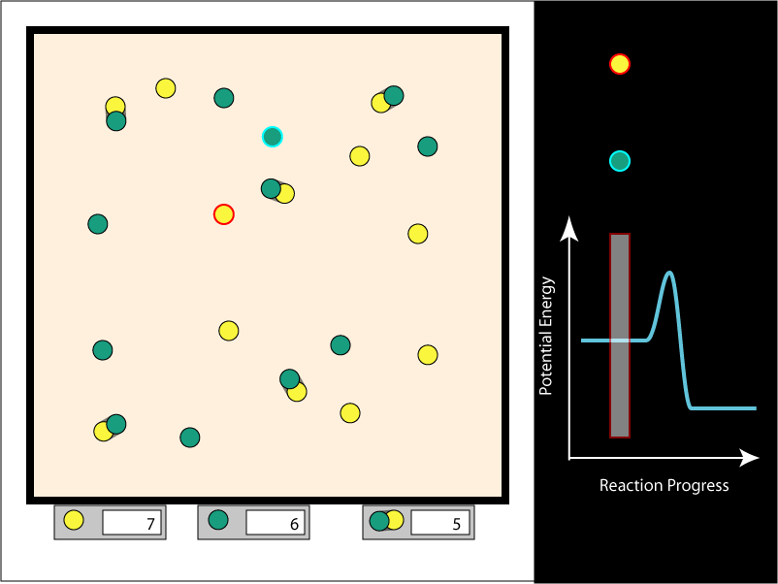

Physical Panel
The left portion will, for the purposes of this discussion, be called the physical panel. It shows green and yellow molecules bouncing around in a reaction box. If one of each type hit each other with sufficient energy, they form a new, combined molecule that has the proper combined linear and angular momentum. If they do not collide with enough energy, they will rebound.
The user will be able to select a single molecule in the physical panel to track in the Reaction coordinates panel (see below). The selected molecule is highlighted with a red border so the user can track it visually. The molecule of the other type nearest to the selected molecule is automatically highlighted in a contrasting color. As the molecules move around in the box, the molecule that gets this second highlight will often change.
The left portion of the play area will have readouts for the number of each type of molecule in the box. The number will be editable by the user.Should be in the control panel as in gas properties
There will be a readout of some sort for the temperature in the box. The user will be able to change the temperature in the box. Just how this will be controlled, and the graphical representation for the source of heat and cold has not be decided. We may use the graphical components from the Gas Properties simulation Yes- good idea

Would it be useful to have a lid as in gas properties to reduce the number of molecules or does this introduce too many other features such as a reduction in temp etc?
I think this would make it too complicated and hard to set ratios, which is what is needed.

Reaction Coordinates Panel
The right portion of the play area will, for the purposes of this discussion, be called the Reaction coordinates panel. It shows a representation of the potential energy of a single molecule in the upper area. The curve shows the potential energy of the user-selected molecule as it gets closer to single molecules of the other type, and as it collides and merges with them.
The vertical bar is a cursor that moves left and right as the distance changes between the user-selected molecule and the closest molecule of the other type.
The molecule representations near the top of the panel correspond to the user-selected molecule (the icon with the red outline) and the molecule of the opposite type that it closest to it (the icon with the cyan outline). As the two molecules they represent in the physical panel move closer together or farther apart, the cursor bar will move right and left in the Reaction coordinates panel, and the two icons above the cursor bar will move closer or farther apart. If they get merge into a single molecule in the physical panel, the cursor will go over the hump of the curve, and the icon will turn into one similar to the one for the merged molecule in the physical panel. The user will be able to manipulate the potential surface with the mouse. The peak of the curve will be movable up and down, as will the level parts of the surface to the left and right of the curve.
I’m not sure I’m visualizing this correctly. It sounds like that each highlighted molecule has it’s own cursor and the molecule is above that cursor; however, in your picture the molecules are far apart but in the graph are right above one another and the cursors look like they are together. My next question is about the significance of the height of each highlighted molecule in the graph. Is there any? Why can’t they move along on their cursor with the graph so the panel doesn’t have to be so tall?
this issue is complicated, and probably not worth trying to handle by email
Agreed. I think it will be easy to explain on a chalk board.

Scrollable Strip Chart
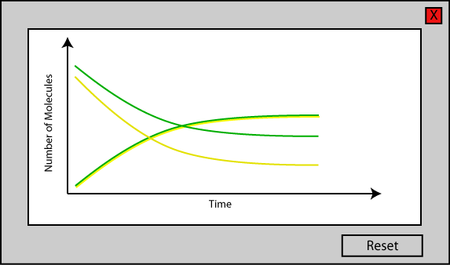
The simulation will have a panel that shows the numbers of each type of molecule in the box over time. It will only be displayed in Panel 3 of the top level panels (see below). The information will be presented as a scrollable strip chart. When the simulation is paused, the user will be able to scroll back and forth in time through the information.

Other Controls
In addition to the standard play, pause, and step controls, there will be a standard stopwatch.

Top-Level Panels
Currently, three top-level tabbed panels are envisioned. Unimolecular reactions will be designed later, and will either be on another panel, or another simulation entirely.

Panel 1
The reaction box will have two molecules in it: one of each type. Its purpose is to let the user see what happens when two molecules collide. In addition to letting the clock drive the model, there will be a mode in which the user can drive the model by moving the cursor bar on the Reaction coordinates panel left and right.Neat idea

Panel 2
The user will be able to control the number of molecules of each type with the controls at the bottom of the physical panel, and the temperature of the system. The user will not be able to control the cursor bar in the Reaction coordinates panel. Why are these different controls isolated in separate panels rather than available on the same one? Linda and I thought the value gained from manually moving the cursor in the PE panel would be greatest, and sufficient, in Panel 1. We don’t think that once a user has done that, the learning goals in Panel 2 would not need that feature.

Panel 3
This will be similar to Panel 2, with the addition of the scrollable strip chart. Why not add this feature as a check box to one or both (or the one if 1 and 2 are combined) rather than as an entirely new panel just to add a strip chart? Sounds good to me.

Notes on the Model
For the purposes of this discussion, I will refer to the product of two molecules that combine to for a larger molecule as a composite molecule. The distance between the components of a composite molecule will vary with time, according to some probabilistic function, yet to be defined. The varying distance will be reflected in the graphics that represent the molecules. As that distance varies, the cursor in the Reaction Coordinates panel will move left and right accordingly.

Addenda

From Linda Koch, 6/13/06
I talked to Wendy about this sim today after the group meeting. One thing
we thought should be added is a GO button, on the right side control
panel. The GO button will allow students to do an experiment. The idea is
that instead of having to hit pause, then set a whole bunch of parameters,
and then hit play, students will just use the GO button. For example, if
they enter a number for the amount of each reactant and then hit GO, the
new molecules will enter the physical box and begin reacting, and at the
same time the stopwatch will start and the strip chart will start recording
(if the strip chart has been opened). If there was already data on the
strip chart, hitting the GO button will restart the strip chart. Only the
new data will appear on the strip chart.
This should not be the only way to add new molecules. If a number of
molecules is entered in the control panel and then 'enter', the new
molecules should be added to the chamber, without any other changes
(stopwatch doesn't start, strip chart doesn't start over).
Please add this feature to the document for this simulation, and let me
know if any of the functions for the GO button are unclear.
Also, In Gas properties we have a heater/cooler for raising and lowering
the temperature of the molecules in the box. Right now this is labeled
"Heat Controller", and along the side by the slider it says "Add /
Remove". In Thermo we try to get students to think of heat as the transfer
of thermal energy. With that definition in mind, adding or removing heat
doesn't really make sense. (Heat is not a substance that can be added or
removed.) If instead we could call this "Temperature Control", and near the
slider say "Raise / Lower" , that would make me much happier. I checked
with Wendy, and she liked this idea too. Please let me know what you
think. Maybe we should bring this up in group meeting.

